1. Claimed_Raised_Reports
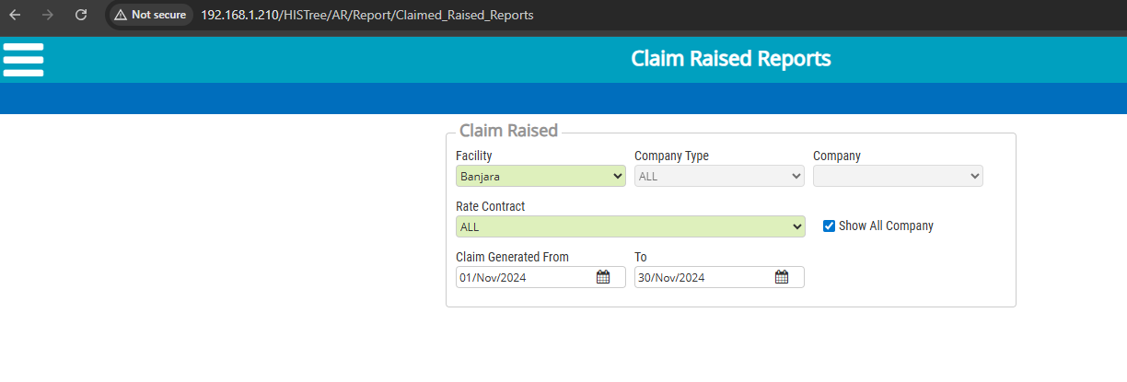
2. Claimed_Received_Amount_Reports
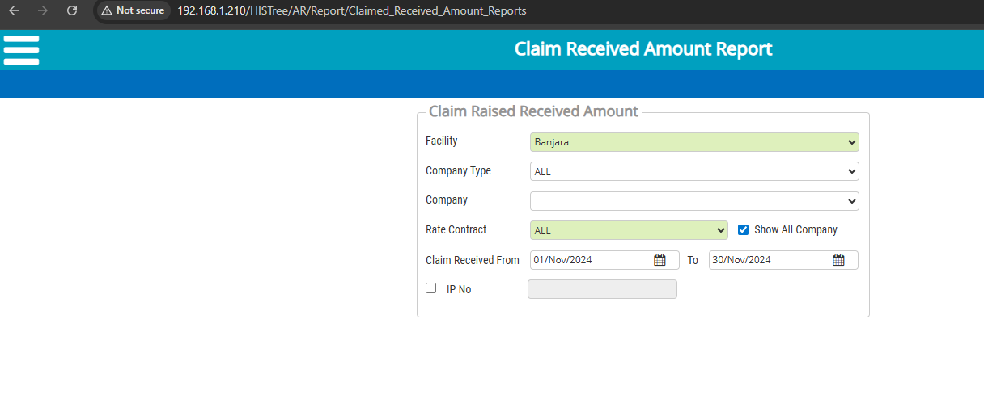
3. Common Scroll
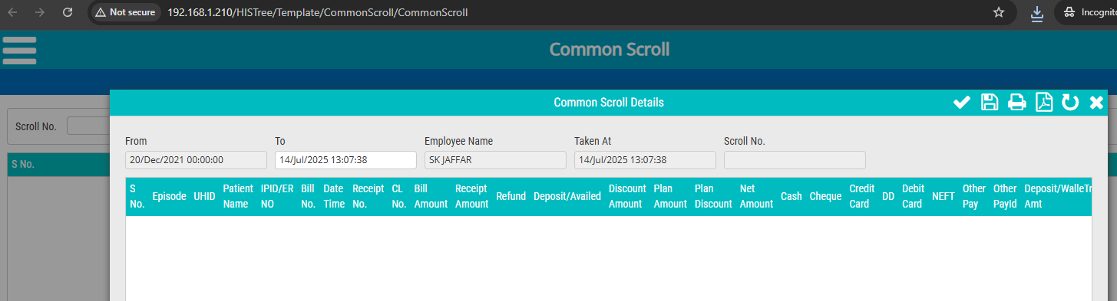

4. Insurance_Company_Report
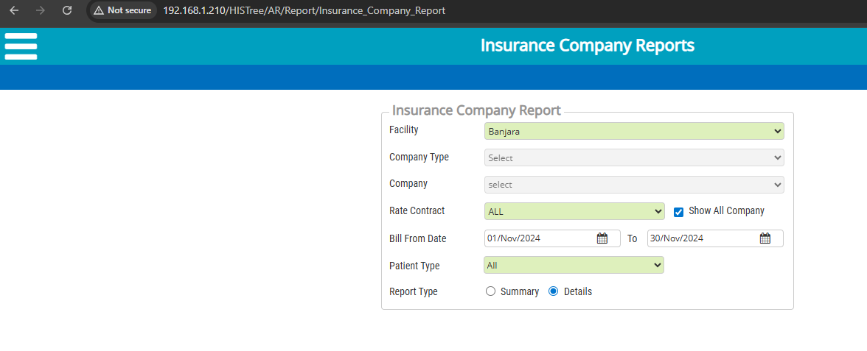
5. Received_Amount_MOP_Reports
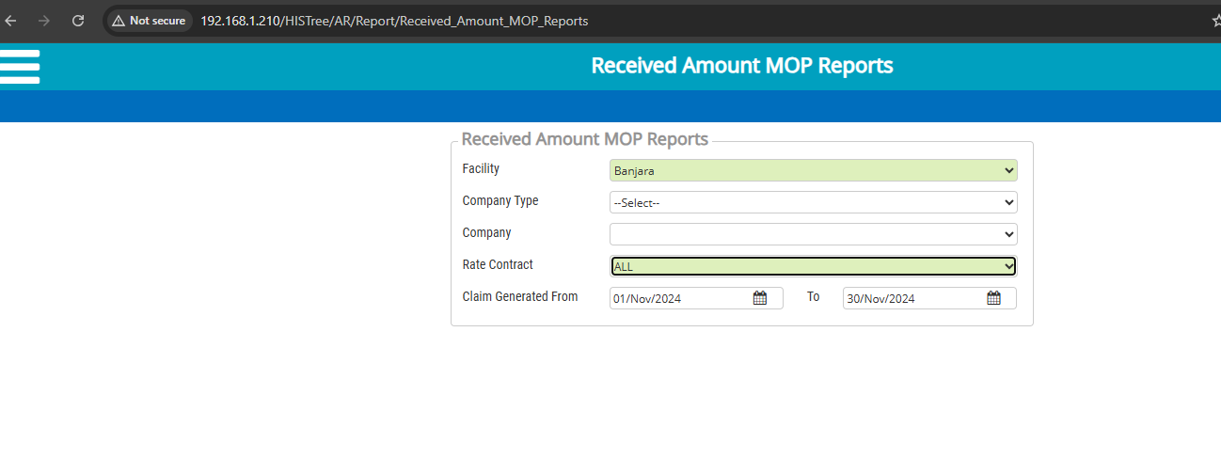
6.CompanyWise_Outstanding_Report
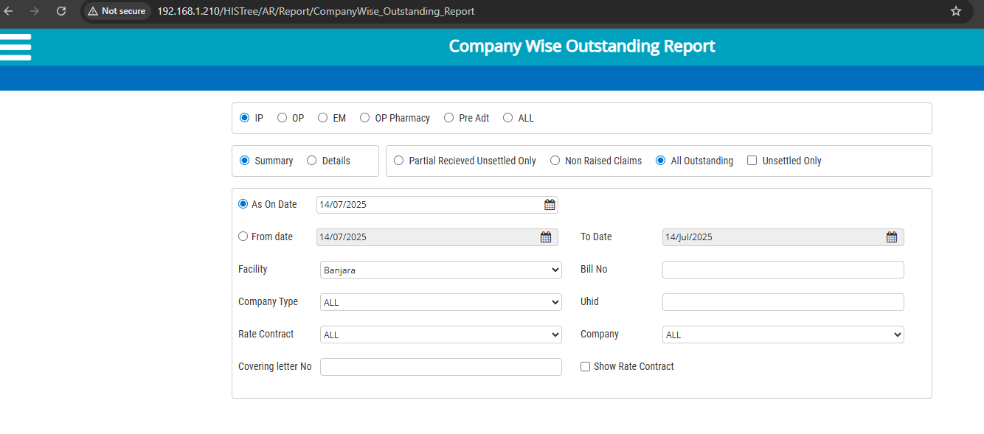

7. Disallow_Report_Ar
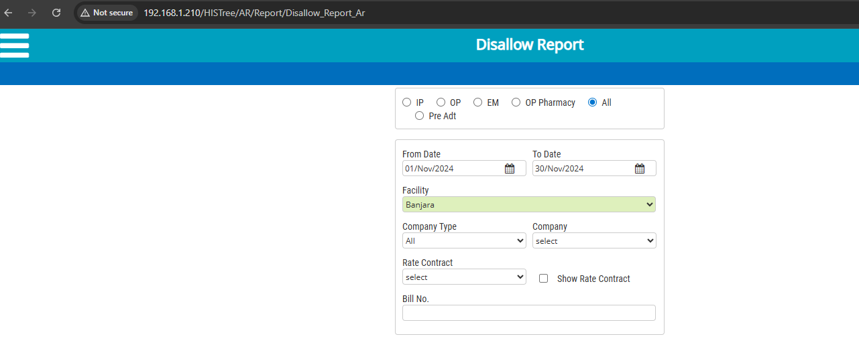

8.Disallow_Report_Ar
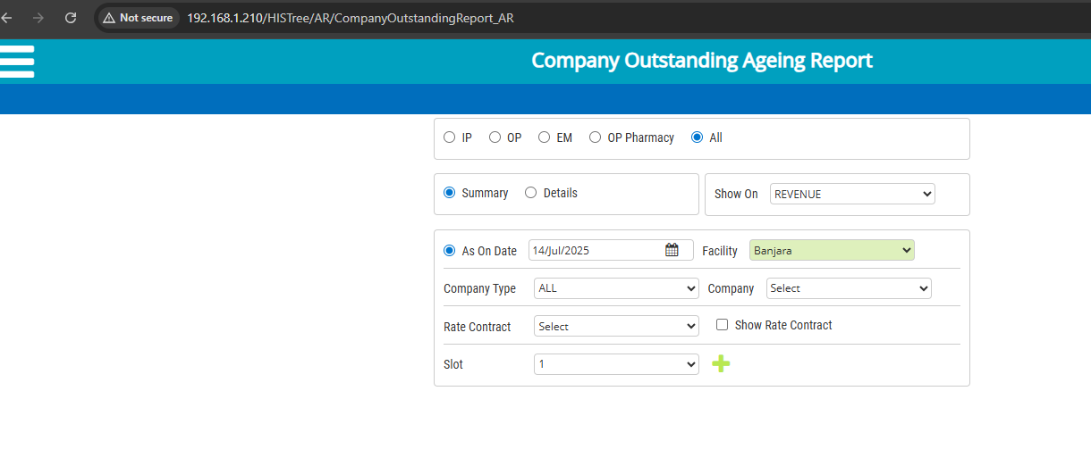
9. ARDeposit_AR
